**Circular No.35/14** **Date: -13/12/2014**

Please Circulate To All Members

**EXCLUSIVE MEETING ON THE ISSUES CONNECTED WITH**

**DISCIPLINARY PROCEEDINGS IN THE BANK**

We reproduce here below the text of AISBOF’s Circular No.146/14 dt.11/12/2014 on the above subject for information of our members.

**With greetings,**

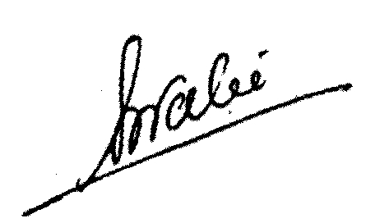

**(Shankerbhai Patel)**

General Secretary

**No.7151/97/14 Date: 11/12/2014**

To,

**The Deputy Managing Director & CDO,**

State Bank of India,

Corporate Centre,

Madame Cama Road,

**MUMBAI - 400 021.**

Dear Sir,

**EXCLUSIVE MEETING ON ISSUES CONNECTED WITH**

**DISCIPLINARY PROCEEDINGS IN THE BANK**

The Banking environment over the last few decades has undergone substantial changes. In the light of the changes that have taken place in the banking operations, coupled with changes in Technology, implementation of Core Banking, Digital Banking, alternate channels, like internet Banking mobile Banking etc., there is now an urgent need to have a relook into the systems and procedures. The rules and regulations governing the disciplinary matters in the banks, to a large extent, have remained static and have not taken into account the present competitive scenario that is prevailing in the market.

**2.** The Federation has been making representations on a continuous basis including, in the CNC meetings, for improvements in the existing disciplinary proceedings. The areas of classification of penalties, the interpretation of rigor period, the limitation of time as regards to the issue charge sheets, appeals and review, application of the Rule 19(3), need to re-look at the grounds rules for suspension, the sealed cover procedure in view of the improved promotional opportunities and the stiff competition in the banks, are some of the issues that need a revisit. We have also brought to the notice of the Management at periodical intervals the changes that have been effected in several banks including the Public Sector Banks in these areas and the need for a similar approach on the part of our Management. We have also been pointing out the need for the review of the functioning of the Vigilance, its jurisdiction and the need for liberal approach in handling the cases of the bank officials in view of the professional hazards that they have been facing in the day to day functioning of the bank.

**3.** We are therefore of the view that an exclusive meeting could be convened to discuss these issues threadbare and come to certain positive conclusion in the backdrop of the risks and responsibilities of the officers’ fraternity in the Bank. Please therefore convene an exclusive meeting of the representatives of the Federation and the Management including those who are actually dealing with the Disciplinary and Vigilance cases in the Corporate Center to consider many of the points raised by the Federation from time to time.

**4.** The issue also figured in our last CNC meeting held on 28th November 2014 and it was expressed by the members of the Federation that in view of the increasing number of disciplinary cases, it is high time that we have to look into the existing procedures and make suitable modifications in the backdrop of what has been stated above.

Please treat the matter as urgent.

Thanking you,

Yours faithfully,

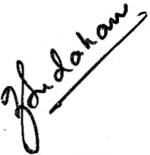

**Y.SUDARSHAN**

**GENERAL SESCRETARY**